Hindi Vidya Prachar Samiti’s
RAMNIRANJAN JHUNJHUNWALA COLLEGE OF ARTS, SCIENCE, AND COMMERCE
(EMPOWERED AUTONOMOUS)

Research Methodology

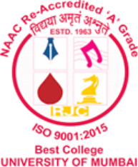

Name: Surajkumar Yadav
Roll no: 10302
Class: MSc. Data Science and Artificial Intelligence Part I

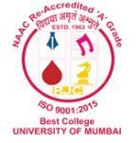
Ramniranjan Jhunjhunwala College
of Arts, Science and Commerce

Department of Data Science and Artificial Intelligence

CERTIFICATE

This is to certify Surajkumar Yadav of MSc. Data Science and Artificial Intelligence Roll No. 10302 has successfully completed the practical of Research Methodology during the Academic Year 2024-2025.
Date:

(Dr. Karishma Rajbhar) External Examiner Prof-In-Charge

